WiFi advertising system in an underground railway station

Liu Rizhang

44201658

November 6 2020

WiFi advertising system in an underground railway station 0

1．Introduction 1

1.1 Writing purpose 1

1.2 Project background 2

2．Requirements 2

2.1 Domain model 2

2.1.1 Wifi advertising system 3

2.1.2 User 3

2.1.3 Domain model class descriptions 3

2.2 User case model 4

2.2.2 User use case descriptions 5

2.2.2 Server use case descriptions 6

2.2.3 Non functional requirements 9

2.3 Object model 10

2.4 Class model 10

2.5 Sequence model 11

# 1．Introduction

## 1.1 Writing purpose

The main purpose of the modeling documents is to reflect the user's problem structure and facilitate communication between the user and the software developer. By further detailing and describing the software data flow and specific requirements, the software requirements model is presented to developers in a more intuitive and comprehensive way. So that it can be used as the basis of software development work, but also as the basis of its confirmation test and acceptance.

The specification is intended for the project development team (including project managers, coders, testers, etc.) and users who propose product requirements

## 1.2 Project background

Wifi advertising is the main way of wifi marketing at present, which means that mobile network operators or enterprises (such as catering, hotel, tourism, hospital, subway, airport, school, etc.) display or push advertising information to mobile terminals such as computers and smart phones that can receive Wi-Fi signals by providing free Wi-Fi. The promotion methods of WiFi ads include: geographical location positioning, regional electronic map, personalized Portal page, free advertising in exchange for Wi-Fi. Advantages of wifi advertising: 1. Wide coverage 2. Mandatory viewing, high recall rate 3. Low CPM and high conversion rate of target audience 4. Detailed analysis reports.

# 2．Requirements

## 2.1 Domain model

Our domain model is depicted in Figure 1. The most importment concepts in the model consists of the Wifi advertising system itself and the system‘s users. Each of these are explained in turned in the following subsections. In the last subsection, Section 2.1.3, we provide detailed descriptions of each of the objects in the domain model in alphabetical order.

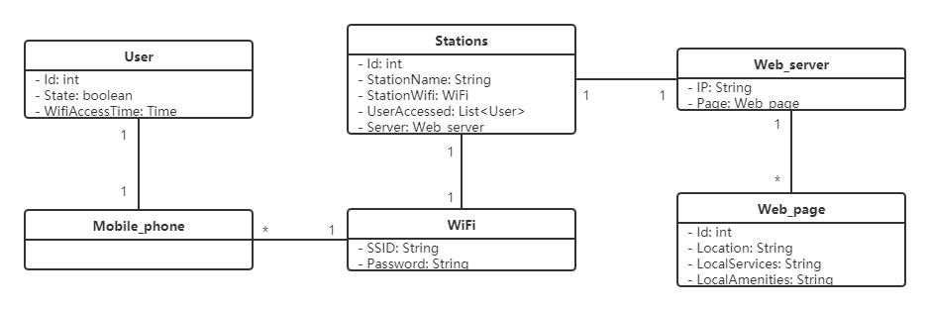Figure 1: Domain model class diagram

### 2.1.1 Wifi advertising system

The wifi advertising system is set up in an underground railway station. No GPS is available in the subterranean area. There is no Internet connection, only closed local networks exist. By storing information about local services and facilities at the station in the local database, users are provided with information about local services and facilities at the station before they connect to wifi, without requiring them to enter the name of the station or any other attributes.

### 2.1.2 User

Users arrive at a subway station they've never been to, armed with a WiFi-only smartphone and a browser app. The user doesn't know where the user is. The user only sees the wall that shows his SSID and password. Users want information about local services and facilities at the station through the wifi advertising system.

### 2.1.3 Domain model class descriptions

The following table provides a detailed description of each class in the domain model, organized in alphabetical order.

|  |  |
| --- | --- |
| Domain model class | Description |
| Mobile_phone | The user's phone is connected to wifi and has a browser installed |
| Stations | The station is an underground railway station, with no GPS, no Internet connection, only a local network shut down. There is a wall that displays its SSID and password, allowing users to connect to wifi. There are some local services and facilities around the underground railway station. |
| User | The user arrives at an underground railway station that the user has never visited, carrying a smartphone that the user has no idea where the user is. The user sees only the wall that shows his SSID and his password. The user wants information about the site's local services and facilities. |
| Web_page | When the user connects to wifi, the browser automatically opens the web page and displays information about the local services and facilities of the station. |
| Web_server | The server's network is connected to wifi, and users can access the server by connecting to wifi. |
| WiFi | The wifi is located in the underground railway station. The wifi is not connected to the Internet, but only to the local LAN connected to the server. The SSID for wifi and its password are posted on the wall of the underground railway station. |

## 2.2 Use case model

We will now use the use case model to further specify the functional requirements of the system. This model is shown in Figure 2. There are only two participants: a user and a server.

Users can connect wifi and check the location of underground railway station, local service information and local facilities information. The server can transmit the location of underground railway station, local service information and local facilities information to users through wifi.

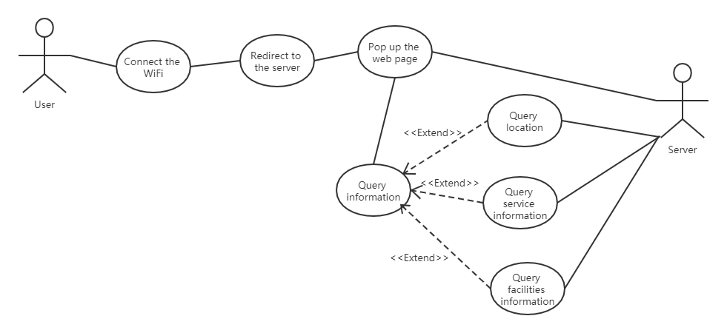

Figure 2: User case model

### 2.2.2 User use case descriptions

|  |  |
| --- | --- |
| **Use case** | Connect the WiFi |
| **Use case description** | Users connect their phones to a local wifi connection |
| **Participants** | User |
| **Precondition** | The user has a phone that can be connected to WiFi. |
| **Postconditions** | The user successfully connected to wifi and entered the local LAN. |
| **The basic path** | 1. Users turn on their phones 2. The user finds the SSID and password on the wall 3. The user connects to WiFi via the SSID 4. User enters password 5. The user successfully connected to WiFi |
| **Optional or exception paths** | 1.1 Password mistake  1.1.1 Re-enter the password on the wall |
| 2.1 Can't search the wifi  2.1.1 Check your phone's network Settings or proximity to wifi |
| **Added** | nothing |

|  |  |
| --- | --- |
| **Use case** | Redirect to the server |
| **Use case description** | Jumps to the specified address when the user visits a web page. |
| **Participants** | User |
| **Precondition** | Successfully connected to WiFi |
| **Postconditions** | Display target page |
| **The basic path** | 1. The user logs into any website 2. Redirect to the target url |
| **Optional or exception paths** | 1.1 Redirection failed  1.1.1 Check your network connection |
| 2.1 The network is not in good condition  2.1.1 Check network configuration |
| **Added** | nothing |

|  |  |
| --- | --- |
| **Use case** | Query information |
| **Use case description** | Users enquire about underground railway station and surrounding information. |
| **Participants** | User |
| **Precondition** | The user successfully visited the website of WiFi advertising system. |
| **Postconditions** | The user selects the type of information that he wants to query. |
| **The basic path** | 1. The user opens the homepage of WiFi advertising system 2. The user views the categories of information provided 3. Users click to view the information they want |
| **Optional or exception paths** | 1.1 The network is not in good condition  1.1.1 Check network configuration |
| **Added** | nothing |

### 2.2.2 Server use case descriptions

|  |  |
| --- | --- |
| **Use case** | Pop up the web page |
| **Use case description** | The server returns the web page to the browser after receiving the network request |
| **Participants** | Server |
| **Precondition** | WiFi redirects the browser's network request to the address of the specified site |
| **Postconditions** | Users see the home page of the WiFi advertising system on their mobile phones |
| **The basic path** | 1. The user's phone sends network requests to the server 2. Server responds to request 3. The server returns web page information to the user's phone |
| **Optional or exception paths** | 1.1 Page no response  1.1.1 Check your phone's network Settings |
| 2.1 Page no response  2.1.1 Contact the staff check the server running status |
| **Added** | nothing |

|  |  |
| --- | --- |
| **Use case** | Query location |
| **Use case description** | The server displays the location of underground railway station through WiFi advertising system |
| **Participants** | Server |
| **Precondition** | The user accesses to the homepage of WiFi advertising system |
| **Postconditions** | The web page shows the location information of the underground railway station |
| **The basic path** | 1. The server received a request for location information of the underground railway station 2. The server queries the location of the underground railway station 3. The server returns the location information of the underground railway station 4. Displays information on the page of the user's browser |
| **Optional or exception paths** | 1.1 The network is not in good condition  11.1 Check network configuration |
| **Added** | nothing |

|  |  |
| --- | --- |
| **Use case** | Query facilities information |
| **Use case description** | The user accesses to the homepage of WiFi advertising system |
| **Participants** | Server |
| **Precondition** | The user successfully visited the website of WiFi advertising system. |
| **Postconditions** | The web page shows information about the surrounding facilities of the underground railway station |
| **The basic path** | 1. The server received a request for information about the surrounding facilities of the underground railway station 2. The server queries the surrounding facilities of the underground railway station 3. The server returns information about the surrounding facilities of the underground railway station 4. Displays information on the page of the user's browser |
| **Optional or exception paths** | 1.1 The network is not in good condition  11.1 Check network configuration |
| **Added** | nothing |

|  |  |
| --- | --- |
| **Use case** | Query service information |
| **Use case description** | The user accesses to the homepage of WiFi advertising system |
| **Participants** | Server |
| **Precondition** | The user successfully visited the website of WiFi advertising system. |
| **Postconditions** | The web page shows the surrounding service information of the underground railway station |
| **The basic path** | 1. The server received a request for information about the surrounding service of the underground railway station 2. The server queries the surrounding service of the underground railway station 3. The server returns information about the surrounding service of the underground railway station 4. Displays information on the page of the user's browser |
| **Optional or exception paths** | 1.1 The network is not in good condition  11.1 Check network configuration |
| **Added** | nothing |

### 2.2.3 Non functional requirements

|  |  |
| --- | --- |
| Name | Description |
| Webpage compatibility | Web pages have to be compatible. They have to be designed for phones, tablet computer and computers, and they have to be compatible with most major browsers |
| Concurrency | Server background programs consider concurrency, so system runs under the concurrency environment based on multitasking techniques. It is used to prevent errors from occurring when there is too much users at one time |
| Object oriented design | The system’s code must be implemented with an object-oriented design with a well-documented class model, and be easy to extend with new functions. |
| Usability | The design of the system's web UI must consider usability, so that people can easily understand how to use the web page |
| security | System designers must consider the security of the system to prevent hackers from modifying the content of the web page |

## 2.3 Object model

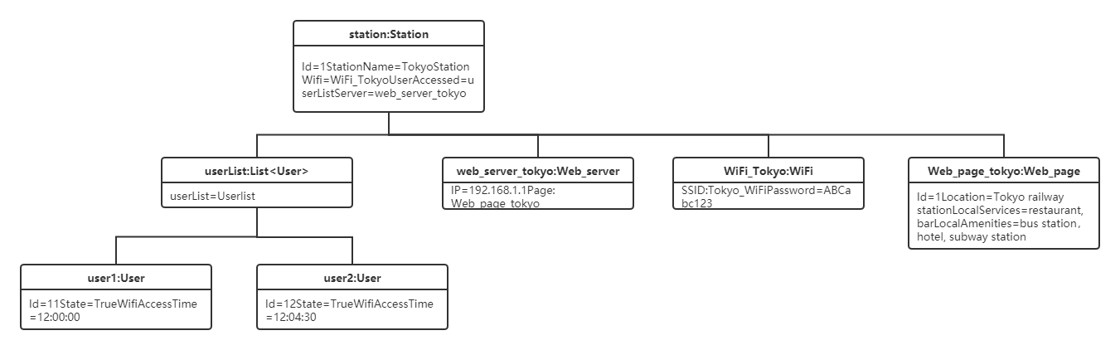 Our object model diagram is depicted in Figure 3. The object diagram shows the objects in the system and their relationships. Use object diagrams to illustrate static snapshots of instances of data structures, classes or components in a class diagram, and so on.

Figure 3: Object model diagram

## 2.4 Class model

Our class model diagram is depicted in Figure 4. A Class diagram shows the static structure of the model in a system, especially the classes in the model, the internal structure of the Class, and their relationship with other classes. Class diagrams do not display transient information.

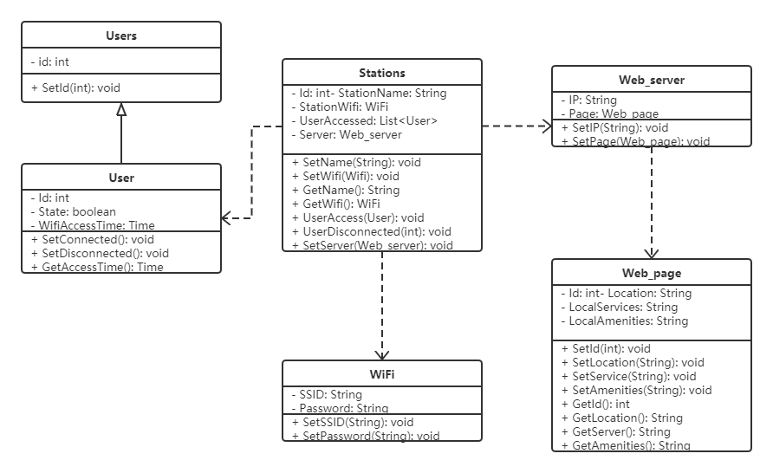

Figure 4: Class model diagram

## 2.5 Sequence model

Our sequence model diagram is depicted in Figure 5.It shows dynamic collaboration between multiple objects by describing the chronological order in which messages are sent between objects. It can represent the order in which a use case behaves when a use routine is executed, in which each message corresponds to a class operation or trigger event in a state machine that causes a transition.

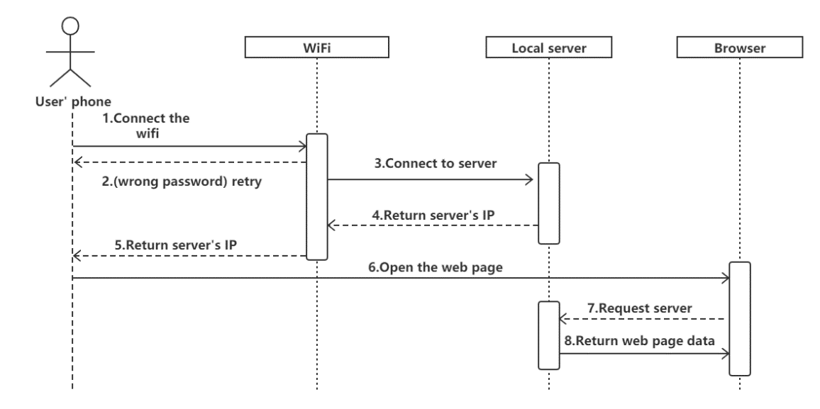

Figure 5: Sequence model diagram